**EXP 20. Demonstrate Infrastructure as a Service (IaaS) by establishing the remote connection, launch the created VM image and run in your desktop using Azure.**

**AIM:**

To demonstrate Infrastructure as a Service (IaaS) by establishing the remote connection, launch the created VM image and run in your desktop using Azure.

**Date**:3.10.2025

**PROCEDURE:**

STEP1: CREATE AN ACCOUNT IN MICROSOFT AZURE.

STEP2: GOTO RESOURCE GROUP AND CREATE A RESOURCE GROUP.

STEP3: GIVE NECESSARY THINGS FOR RESOURCE GROUP.

STEP4: CREATE AVIRTUAL NETWORK FOR TO CREATE AVIRTUALMACHINE.

STEP5: NOW CREATE A VIRTUAL MACHINE WITH UR IPADDRESS ANUSERNAME AND

PASSWORD FOR YOUR VIRTUAL MACINE.

STEP6: AND YOUR VIRTUAL MACHINE IS DEPLOYED.

STEP7: NOW CONNECT THE VIRTUAL MACHINE AND DOWNLOAD THE RDP FILETO OPEN YOUR WINDOWS VIRTUAL MACHINE.

STEP8: CREATED ANEW WINDOWS VIRTUAL MACHINE

**IMPLEMENTATION:**

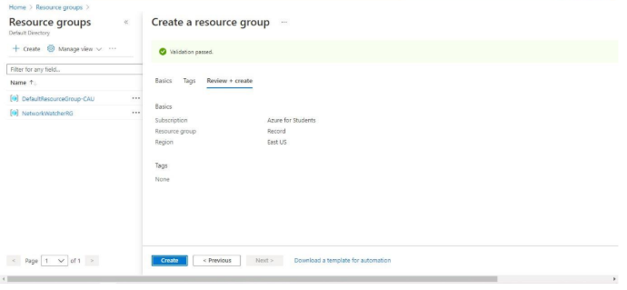

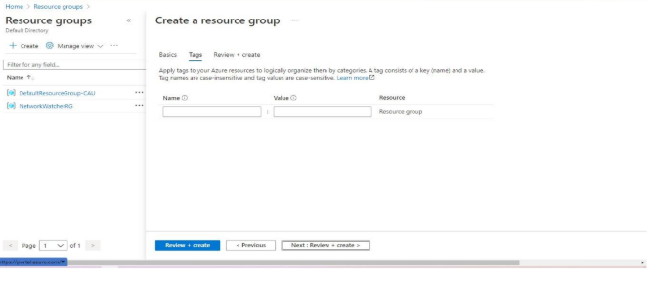

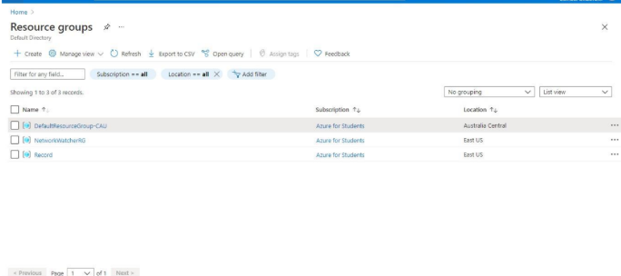

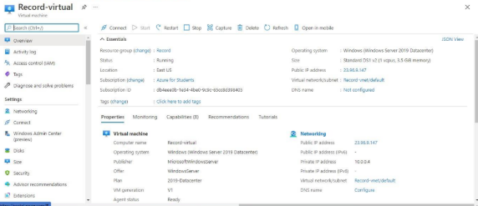

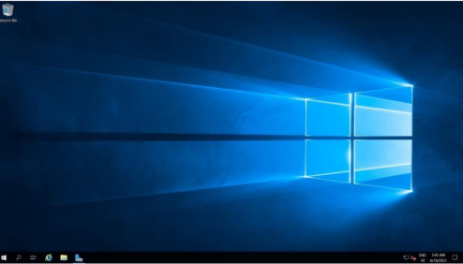

**Result:**

Infrastructure as a Service (IaaS) by establishing the remote connection, launch the created VM image and run in your desktop using Azure has been demonstrated.